 | WELCOME TO  South Walney Junior School  Amphitrite Street South, Walney Island, Barrow-in-Furness, LA14 3BG
Staff and governors are rightly proud of their school and ambitious for their pupils. These positive views are shared by parents and grandparents. You, and your team, ensure that pupils have an extremely safe and secure environment by promoting the clear message that safeguarding is everyone’s responsibility. |  | 

Information Pack for Parent/Carers

2025-2026
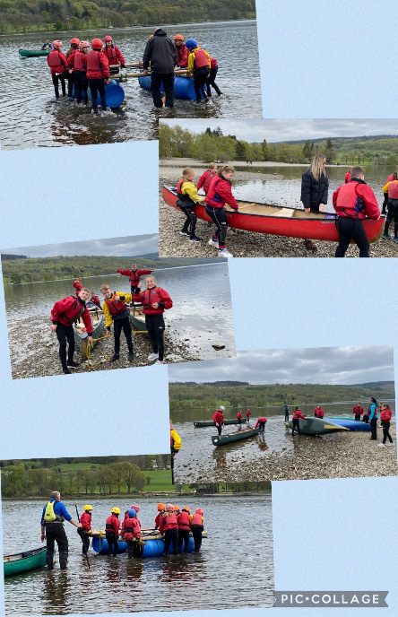
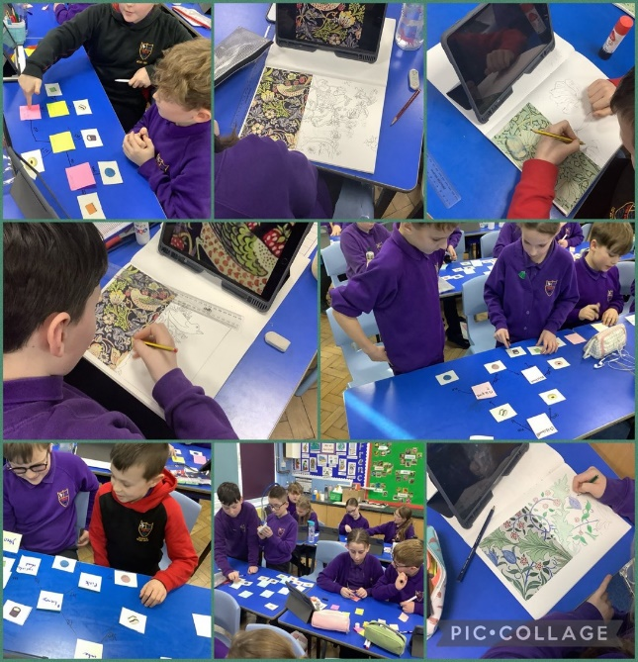
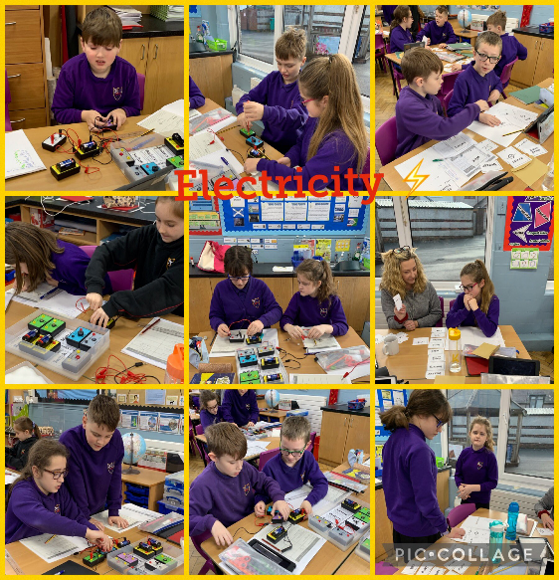
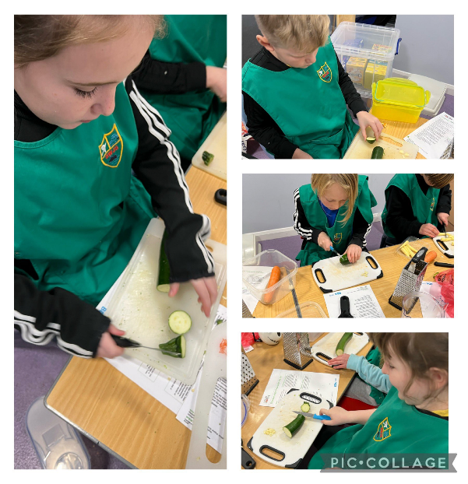

SAFE
A Supportive school helping pupils Achieve and Flourish on a foundation of Excellence
Contents
Information for starting school 4
School Times 4
Bringing and collecting your child 4
Parking 4
Mobile Phones 4
Lost Property 4
Healthy Eating, Snacks and Fruit Tuck Shop 4
Water 5
Lunch 5
Free School Meals – Pupil Premium 5
House Teams, Merit Points, and Golden Time 5
Swimming 5
School Trips 5
Attendance 6
Medical Conditions 6
Holidays 6
Communicating with Parents 7
Breakfast and After School Club 8
Opening Times 8
Location 8
Cost 8
Routine 8
Collection 8
Uniform 10
School Uniform 10
Labelling 10
PE Kit 10
Swimwear 10
Uniform Suppliers 10
Parental Guidance 11
Preparing your child for school 11
Showbie 11
Reading 11
How do we teach reading at South Walney Junior School? 11
Keyboard Lessons 13
School Term Dates 14

Consent Forms to be completed and returned to South Walney Junior School:

• Data Collection Enrolment Form (paper copy)
• Trips, Images, Pain Relief Consent (Details and consent via Parentmail)
• Internet consent (Details and consent via Parentmail)
• Home/School Agreement (Details and consent via Parentmail)

Information for starting school

School Times
9.00 am – 12.00 pm (School gates open at 8.50am)
1.00 pm – 3.30 pm

Morning Break: 10.20 am – 10.40 am (Year 3 and 4)
10.40 am – 11.00 am (Year 5 and 6)
Lunch Break: 12.00 pm – 1.00 pm Lunch break

Bringing and collecting your child
Year 3 New Starters
Parents are asked to bring their Year 3 children to the Year 3 gate (back street shared with Hogue St). There, you will be welcomed by the Y3 Teaching Staff. Likewise, at the end of the school day, children will not be allowed to leave the school until a parent/guardian (or somebody elected by the parent/guardian) is there to collect the child. No child would ever be handed over to another adult without the permission of the parents. Please be punctual during drop –off or collection.

PLEASE NOTE: No dogs in the playground please.

Parking
Please do not park on the zig-zag and double yellow lines outside the school. They are there to make the road safer for your children. Please walk whenever possible to reduce congestion in our community.

Mobile Phones
We actively discourage children from bringing mobile phones to school. However, under exceptional circumstances, any mobile phones brought into school must be placed in a named packet, switched off and left in the school office during the day. South Walney Junior School does not accept any liability for lost or damaged mobile phones that are brought onto the premises.

Lost Property
The lost property box is kept in a cupboard in the entrance area. If your child misplaces anything around school and it is unlabelled, it will be found in the lost property box.

Healthy Eating, Snacks and Fruit Tuck Shop
We hope to have our Tuck Shop up and running soon As part of our Healthy Eating policy, we actively discourage sweets and unhealthy snacks in school, however, crisps are allowed on a Friday. The pupils run their own daily Healthy Tuck Shop and sell a selection of fruit for between 20p and 50p at break time.

Water
Children are encouraged to drink plenty of water and will need their own, named, water bottle. This can be filled throughout the day either in the classroom.

Lunch
Dolce provide an excellent selection of healthy, nutritional meals for our pupils every day which are cooked fresh on-site. Pupils can choose their own meals in class (by 9.30 am), or parents can pre-order from home using the app. Meals currently cost £3.10 per day. Dolce, in conjunction with Live Kitchen, operate a cashless system – please see letter from Dolce regarding different payment options.

Free School Meals – Pupil Premium
In September, your child will be making their transition into Key Stage 2 and this means that you are no longer entitled to Key Stage 1 Universal Free School Meals. However, your child may still be entitled to Free School Meals, so you are strongly urged to find out if you are eligible by visiting https://www.cumbria.gov.uk/childrensservices/schoolsandlearning/freeschoolmeals.asp

By applying successfully for Free School Meals, the school will attract £1,345 of Pupil Premium funding each year your child is with us - even if your child chooses not to have a free school meal or your family financial circumstances change and you are no longer eligible for free school meals. This is a very important funding stream for school. PLEASE apply if you are eligible. All this additional funding is used to purchase much needed learning resources, as well as providing additional support and further opportunities for our pupils.

House Teams, Merit Points, and Golden Time
We have four House Teams:

Abbey – Blue Biggar – Green Jubilee – Yellow Piel – Red

Children will be allocated their team by their class teacher and parents are asked to purchase their PE T-shirt in their House colour. On Sports Day, points are awarded and the Trophy goes to the team with most points. In addition, children can earn merit points for good work, behaviour, being polite, positive attitude to school life, etc. 40 earned merit points per term allows the children to take part in Whole School Golden Time.

Swimming
All children are given the opportunity to swim for one term each year. There is a charge of approximately £30.00 per term which is a contribution towards the total cost of pool hire, swim instructors and transportation. We ask that this is paid on Parentmail before the first session commences.

School Trips
Children will not be taken out of school unless parents have been notified and the Trips Consent form has been signed.

In addition to ad hoc day trips, the school organises an annual residential trip for each year group:

Year 3 Two days/one night residential to Eskdale
Year 4 Two days/one night residential to York
Year 5 Two days/one night residential to Coniston
Year 6 Three days/two night residential to London

Deposits for each trip are required at the time of booking with further instalments required. You will be notified of this at the time of booking.

Attendance
A child is expected to attend school every day it is open unless he or she is unwell, has to attend hospital or has a dental appointment. If your child is absent from school due to illness, parents must notify school, ideally by Parentmail - our preferred method, or by telephoning the school office to leave an absence message. If school has not been notified by 9.30 am of a child’s absence, parents will receive a text message reminding them to contact school.

If you need to take your child out of school for an appointment, please give the child a letter addressed to the class teacher explaining the reason and stating the time; come to the front entrance and the office staff will collect your child from the classroom. Take your child to the school office at the front entrance on returning from an appointment during school hours. All children must sign out and in on our electronic entry system located in the Entrance lobby.

Medical Conditions
Our school is committed to ensuring parents feel confident that effective support for their child’s medical condition will be provided and that their child will feel safe at school by putting in place suitable arrangements and procedures to manage their needs. We therefore request that parents provide us with sufficient and up-to-date information about their child’s medical needs.

Where applicable, parents will work with our SENDCo in the drafting, development and review of their child’s Individual Health Care Plan (IHCP). An IHCP helps ensure that our school can effectively support any child with a medical condition. It provides clarity about what needs to be done, when, and by whom, and aims to capture the steps which we should take to help your child manage their condition and overcome any potential barriers to get the most from their education.

An IHCP will often be essential, such as in cases where conditions fluctuate or where there is a high risk that emergency intervention will be needed, and are likely to be helpful in the majority of other cases, especially where medical conditions are long-term and complex. However, not all children will require one.

Holidays
Holidays during term time are strongly discouraged as it interrupts the child’s education and creates gaps in the child’s knowledge. Government regulations mean that Headteachers will not authorise holidays taken during term time. Absence due to exceptional circumstances should be applied for in advance, and may involve an interview with the Headteacher. More details and information can be found in the Attendance Policy.

Communicating with Parents
We use Parentmail to communicate with all our parents. This allows us to send you text messages and email letters in seconds. We also use Parentmail to allow you to:

- report pupil absences
- book places in Breakfast and After School Club
- make online payments using credit, debit cards or PayPal
- make Parents Evening appointments
- complete consent forms and surveys.

You will be asked to connect with our school the day following your child’s admission. We urge you to download the App and enable push notifications so that you never miss a communication from us.

Parents are strongly encouraged to sign up to Showbie and join the corresponding parents groups that your child is in. Showbie is updated regularly with information about your child’s year group (reminders, events, special days etc).

We also celebrate our successes on Twitter (@swalneyj), and regularly update our website (www.swalneyj.cumbria.sch.uk). .

Breakfast and After School Club

Both Clubs are based in our School House which is the ideal place to leave your children before or after school. We can be flexible to meet your needs: bookings can be on a regular, or on an ad hoc basis, and children can attend any number of days a week. The preferred method for booking is using the Parentmail App. If you have any problems/ difficulties with this, the office staff will be able to assist.

Opening Times
7.30 am – 8.45 am (Breakfast Club)
3.15 pm – 6.00 pm (After School Club)

Location
The School House Tel: 01229 474449
Mikasa Street
Walney Island Email: admin@swalneyj.cumbria.sch.uk
Barrow-in-Furness
Cumbria LA14 3EG

Cost
Breakfast Club (includes breakfast): £4.00 (7.30 am – 8.45 am)
After School Club (includes snacks): £5.00 (3.15 pm – 5.00 pm)
£7.50 (3.15 pm – 6.00 pm)

Routine
Breakfast Club: No responsibility will be taken for children arriving before 7.30am. Entrance to the School House is by the front door located on Mikasa Street. Children will remain in the care of the Club staff until 8.45am when they will be taken either to South Walney Infant and Nursery School or into the Junior School. Key Stage 1 children will be escorted to their classrooms whilst Key Stage 2 children will be allowed to join their friends in their classroom under the supervision of a member of staff.
After School Club: The Club starts at 3.15pm. Children can be collected from South Walney Infant and Nursery School by prior arrangement. Children from the Junior School will be asked to meet the Club staff in the school Library before walking across the playground to the back door of the School House. Once at the Club, the register is taken and the children have a chance to settle down, relax and have a drink and a little snack. Weather permitting they can play in the outside area or with an activity inside.

Collection
Only people authorised by parents/carers are allowed to collect your child. All children should be collected by 6.00pm. If you are running a little late please let us know by calling the School House on 01229 474449. Children who are not collected by 6.00pm will be charged a late pick up fee of £10.00.
Numbers are limited to ensure a safe adult:child ratio, so please ensure that you book your child’s place in advance. Bookings and payments should be made using the Parentmail App.
You will also be required to completed a Registration Form and agree to the Club’s Terms & Conditions.

Uniform

School Uniform  - Black tailored trousers/black skirt/tunic/ tailored shorts  - Purple polo shirt with school logo*  - Purple sweatshirt/cardigan with school logo*  - Purple and white check dress (summer)  - White/black socks  - Sensible black shoes  - Black/white trainer shoes/white sandals (if preferred in summer)  * Logo stitch-on badges may be purchased from school at a cost of 70p each  Labelling | PE Kit  - Plain T-shirt in ‘house’ colour  - Blue shorts  - Trainers  Each year group will have a PE day. On these days, the children will come to school in their PE kit (and dressed appropriately for the season). PE days will change each half term due to the PE curriculum & PE coaches.  Swimwear  - Girls to wear one-piece swimsuit, not bikinis. Boys to wear swim trunks, not shorts.  For safety, jewellery should not be worn in school. If children have to wear earrings they must only wear one pair of studs, which they have to remove for PE and for swimming
Please remember to label all items of your child’s uniform and kit. It is much easier to identify missing garments if they have been labelled.

Uniform Suppliers
School sweatshirts, cardigans, polo shirts, PE shorts and T-shirts with the school logo, as well as trousers, skirts, pinafores, bags, coats etc can be purchased from Identity. Please register on their website to make an appointment to visit the store, or call 01229 823584 if you and your child require a dedicated 1:1 consultation. Alternatively, all items can be purchased directly from their website without needing to visit the store:

Identity Tel: 01229 823584
Unit 2, Peter Green Way
Furness Business Park Website: www.oneidentity.co.uk
Barrow-in-Furness
Cumbria LA14 2PE Email: sales@identityltd.co.uk

Plain purple tops can also be purchased in local Supermarkets and either have the logo embroidered on or stitch-on logo’s can be purchased from the school office.

Parental Guidance

Preparing your child for school
- Talk about school in a positive way. Make sure your child knows what to expect.

- Children will need to dress and undress for extra-curricular PE sessions and when swimming. Take time at home to encourage your child to get dressed quickly and by themselves.

- Your child should be able to know where to find their name on all their clothes so that they are able to look for and identify them if they have ‘lost’ them.

- At home, read as much as you can with your child, and listen to them reading aloud to you. See ‘How do we teach reading at South Walney Junior School’.

Showbie
We use Showbie, an easy-to-use app, alongside our traditional methods of teaching. Showbie is used to send work to the pupils, for teachers to provide feedback, and for pupils and parents to communicate directly with their teacher. You will be provided with a Parent code to access this online learning platform, and we would appreciate you signing in as soon as you possibly can.

Reading
Your child will be given a reading book which we see as a “home reader”. Children are strongly encouraged to read their reading book to an adult at home each night. Reading Records are accessed via the Showbie App.

How do we teach reading at South Walney Junior School?
We teach reading explicitly through high quality texts in English. We use pre-reading in other subjects (academic reading). We practice reading daily; either individually, or in groups. We read aloud a good quality book to our children every day.

We use the Big 5 to teach reading to our children:

Phonic Awareness – hearing the separate sounds in a word.
Phonics — knowing the letters and the sounds they represent eg s/p/ea/k (ea = long ‘e’ sound) (see Letters and Sounds sheet).
Fluency – using ghosting (reading together ),echoing (reading a line to the child before they read it back) and shared (reading a line or paragraph each). We work on accuracy, speed (encouraging them to read faster but still with meaning) and expression.
Vocabulary – we teach vocabulary explicitly. We look at the word in context in the text and try to work out the word meaning from this. We do a vocabulary check at the beginning of most lessons, including the foundation subjects such as History and Geography which teaches academic vocabulary too.
Comprehension – We teach a progressive system :VIPERS (Vocabulary, Inference, Prediction, Explanation, Retrieval and Summary). Year 3 and 4 work mostly on
retrieval, vocabulary and Inference. Year 5 and 6 concentrate on the rest.

When practising our reading, our adults will:
- Point to the sounds in the words and help us to work out what sound they make, ie that the sound in bread is an ‘e’ sound’.
- Help us to split words up using phonics eg m/e/ss/y or with more complex words use syllables per/form/ance (3 syllables) .
- Help us to learn the tricky words on our flashcards.
- Read with us, ghosting the text, echoing or sharing the reading. Show us how to read with expression, pausing at the punctuation.
- Help us to read more quickly and not lose our place by showing us how to read from punctuation mark to punctuation mark. Help us use our fingers or overlays.
- Ask us what the words mean. Encourage us to work out what the words mean in the context of the text. If not, tell us what the words mean or use a dictionary.
- Ask us questions about the text such as: what does the character feel? (inference), help us to sum up what has happened so far (summary) or predict what comes next.

Keyboard Lessons

We are delighted to offer each child at South Walney Junior School the opportunity to learn to play the keyboard taught by a teacher from Cumbria Music Service. This weekly opportunity is provided free of charge to parents.

School Term Dates

